Third Terminal Examination- 2082
Green Society Public School
Class: Nursery F.M.: 50
Sub: Rhymes and Conv. P.M.: 18

- What is your Name? 5
- How old are you? 5
- In which class do you read? 5

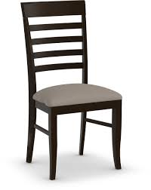
- Identify the picture? 5

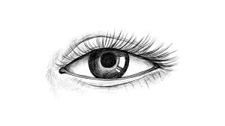
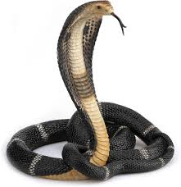

- Rhymes. 5
- Dance 5
- Neat and clean 10
- Regularity 10

Third Terminal Examination- 2082
Green Society Public School
Class: Nursery F.M.: 50
Sub: English (Oral) P.M.: 18

- What is your name? 5
- How are you? 5
- In which class do you read? 5
- How old are you? 5
- What is your principal's name? 5
- What is our national flower name? 5
- Read the given letters? 10
Kk Ll Mm Nn Oo
Pp Qq Rr Ss Tt
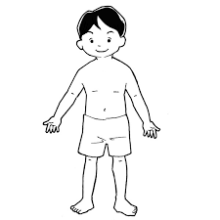
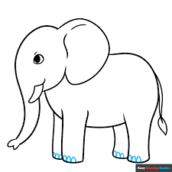


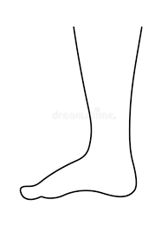
- Identify the pictures. 5

- Neat and clean. 10

t];|f] q}dfl;s k/LIff– @)*@
lu|g ;f];fO{6L klAns :s'n
sIff– g;{/L k"=M %)
ljifoM g]kfnL -df}lvs_ p=M !*
- tkfO{sf] gfd s] xf] < %
- tkfO{ slt jif{sf] x'g' eof] < %
- tkfO{ slt sIffdf k9\g'x'G5 < %
- tkfO{sf] ljBfnosf] gfd s] xf] < %
- tkfO{nfO{ dgkg]{ t/sf/Lsf] gfd s] xf] < %
- xfd|f] /fli6«o km"nsf] gfd s] xf] < %
- tnsf] cIf/x? eGg'xf];\ . !)
/ n j z if ; x If q 1
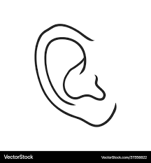


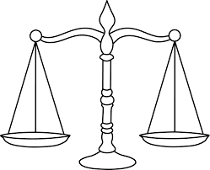
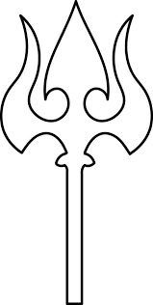
- tnsf] lrqx?sf] gfd eGg'xf];\ . %

Third Terminal Examination- 2082
Green Society Public School
Class: Nursery F.M.: 50
Sub: Maths (Oral) P.M.: 18

- What is your name? 5
- How are you? 5
- In which class do you read? 5
- How old are you? 5
- Say (1 to 30) 10
- Say (!–@)) 10
- Read the following numbers? 5
11 12 13 14 15
- Identify the pictures. 5

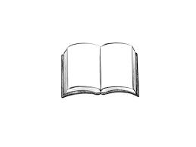
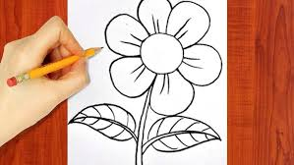
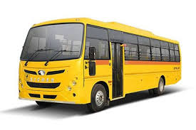

Third Terminal Examination- 2082
Green Society Public School
Class: Nursery F.M.: 50
Sub: Maths (Written) P.M.: 18

1. Match the same numbers. 5
21 22
22 21
23 25
24 23
25 24
2. Circle the Devanagari numbers 20. 5
20
10
16 15 20
8 20 3
20 9 12
20

3. Write the numbers 14 to 20. 6
14

4. What comes before? 5
= 22 = 17 = 11
= 28 = 10
5. What comes after? 5
6= 13= 20=
9= 15=
6. Circle the same Devanagari numbers. 5
*M * !! !%
!@M # !@ @
!%M !) & !%
!*M !* !( %
@)M !# @) !$
7. Count and write. 10
=

=
=

=

=

8. Complete the Devanagari numbers. 5
!)

9. Colour the shapes. 4

Heart Rectangle
Third Terminal Examination- 2082
Green Society Public School
Class: Nursery F.M.: 50
Sub: English (Written) P.M.: 18


1. Match the letters with the correct pictures. 8
A
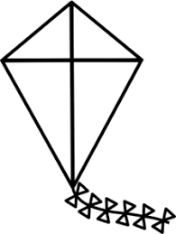
F

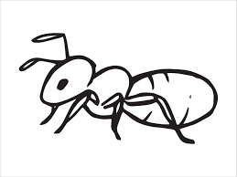
I

K
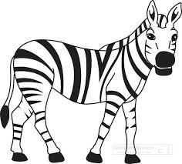
S
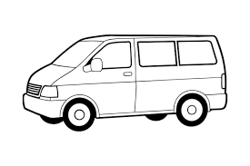
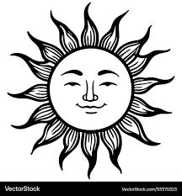
O


V

Z
2. Circle the letter of 'M'
M
A O N
M M M
P A L
M M

3. Copy the same letters. 5
H I J K

L M N O

4. Match the same capital and small letters. 6
R t
T r
H e
E h
W z
Z w

5. Write (Qq to Zz) 10

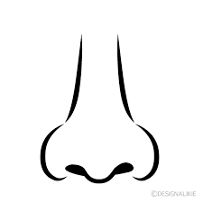


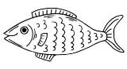
6. Write the first letters of given pictures. 8



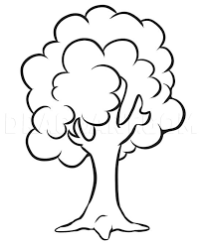
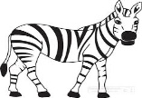


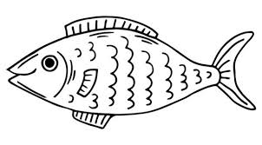
7. Colour the picture. 5


t];|f] q}dfl;s k/LIff– @)*@
lu|g ;f];fO{6L klAns :s'n
sIff– g;{/L k"=M %)
ljifoM g]kfnL -lnlvt_ p=M !*
!= p:t} cIf/;Fu hf]8f ldnfpg'xf];\ . %
s r
r s
em km
7 7
km km
@= ækÆ b]lv ænÆ ;Dd n]Vg'xf];\ . *

#= ækmÆ cIf/df uf]nf] -)_ 3]/f nufpg'xf];\ . %
s km n /
r j km
km 5 h
n ; km
/ km z x

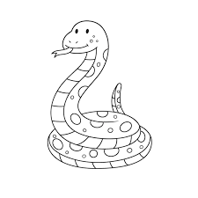
$= lrq / cIf/sf aLrdf hf]8f ldnfpg'xf];\ . %

s
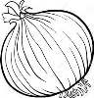
;

a

3
n
%= p:t} cIf/nfO{ ;fg'{xf];\ . ^
6 7 8 9 0f t

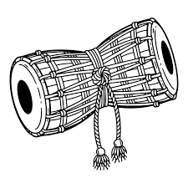


^= lrq x]/L klxnf] cIf/ n]Vg'xf];\ . ^

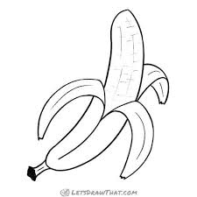
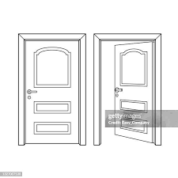
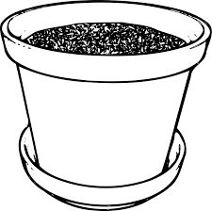

&= vfnL 7fpF eg'{xf];\ . !)
w km
o z x
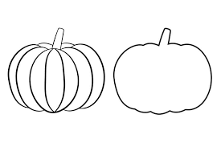
*= /ª eg'{xf];\ . %

